1. How many rows?
2. How many columns?
3. What paying symbols
4. What symbol pays how much?
5. How many paying lines?
6. Theme?

BUTTONS:

1. Spin
2. Info
3. Bet amount

To show:

1. Gameplay
2. Win
3. Jackpots X 3?
4. Credits

Symbols:

1. Premium: 3X?
2. Normal:
3. Wilds

Other:

* Loading screen with info
* Show pay lines
* Turbo button?

**Age warning when entering the site**

**Bonus:**

Coin bonus?:

* Expanding reels

Expanding premiums on normal or only on bonus?

Jackpot feature?:

* How many free spins?
  + 3 bonus symbols
  + 4 bonus symbols
  + 5 bonus symbols
* Extra spins in the bonus
  + 2 bonus symbols
  + 3 bonus symbols
  + 4 bonus symbols
  + 5 bonus symbols

**Winning odds:**

* Legally required odds?

**Admin panel:**

* Control odds (warning when breaking legally required odds).
* Control free spinning amount.
* A summary of wins and losses over time
* Amount earned overal

Win per symbol:

Visual animations:

* Shoots reels open when enough coins are hit
* Line-hit:
  + Blinking symbols (gone and back)
  + Show pay lines
* Big hit animation
* Spin animation

Sounds:

* Shooting sounds when hitting coins in coin bonus.
* Background music.
* When hitting bonus symbols.

Research:

Source: <https://jackpotcasino.be/what-is-the-payout-percentage-for-belgian-online-casinos-and-gambling-halls/>

Internet Casino Pay ratio

* Payout percentage Casino777 98.32% Play Now Internet Casino
* Payout percentage Golden Palace 97.02% Play Now Online Slot GoldenPalace.be
* Payout percentage Circus.be 96.73% Play Now Online Speelhal Circus.be
* Payout number of Belgian Online Arcade
* Online Slot Payrate
* Golden Vegas payout percentage 98.87% S
* Slide carousel.be Payout percentage 97.96%
* Magic Wins payout percentage 97.87%
* Circus.be payout percentage 96.74%

Source: <https://meneercasino.com/online-casino-tips/online-casino-hoogste-winkans-rtp>

De meeste online slots hebben een RTP van ergens tussen de 95% en 97%.

Mega Moolah heeft een RTP van 96,98%. Dat is best hoog. Maar van elke euro die je inzet op Mega Moolah, gaat 8,8 cent naar de miljoenenjackpot. Als je die jackpot buiten beschouwing laat, is de RTP nog maar 88,18%.

lot provider RTP

Book of 99 Relax Gaming 99%

Marching Legions Relax Gaming 98,12%

White Rabbit BTG 97,72%

Big Bad Wolf Quickspin 97,34%

3 Charms Crush iSoftBet 97,23%

Spartania Stakelogic 97,22%

Source: <https://www.casino.nl/casino-bestemmingen/belgie/>

Het minimale uitkeringspercentage van de speelautomaten is wettelijk vastgelegd op 84%.

Source: <http://www.murderousmaths.co.uk/extfiles/maths_odds_in_slot_games.htm#:~:text=You%20can%20calculate%20the%20odds,the%20number%20of%20possible%20combinations>.

A classic 3-reel online slot operates through a random number generator. When you play the slots, it sets the machine in motion with the system generating a random combination of numbers or symbols on the screen. You’ll need to keep this random symbol combination in mind when considering the odds for online slot games.

Let a random number generator — a computer chip — determine the combination of symbols that appear when the reels stop. In other words, use a chip to control where the reels stop on a spin, but create the illusion that the wheels stopped on their own.

Source: <https://www.casinocitytimes.com/donald-catlin/article/non-random-randomness-part-2-innocent-until-proven-guilty-1244>

bootstrap operation

the generally accepted form of a random number generator (RNG). It is a recursive function defined by a pair of equations as follows:

(R1) a0 = seed

(R2) an+1 = f (an)

it is essential that the number "seed" on the right hand side of (R1), the first number in the sequence of random numbers, be chosen in a completely random fashion.

This is generally accomplished by using a real time clock and some command to set the seed by noting the current time as this command is executed.

the infinite sequence a0, a1, a2, a3, ... is referred to as a sequence of pseudo random numbers.

the trick here is to choose the function (algorithm, formula, procedure, instruction) f to be complicated enough that the resulting sequence of pseudo random numbers "looks and acts" like a truly random sequence.

linear congruential generator and generates integers. The general form looks like this:

an+1 = (ran + c) mod m (1)

The RNGs designer chooses the integers r, c, and m.

The algorithm multiplies the nth integer in the sequence, an, by the integer r and adds the integer c to the result.

This integer is then divided by the integer m and the integer remainder after the division is completed is the integer an+1.

Example:

Suppose that r = 7, c = 5, m = 13. If seed = 4 then the second number in the sequence would be (7 x 4 + 5) mod 13 or 33 mod 13. 33 divided by 13 is 2 with a remainder of 7 so a1 = 7. The next number is (7 x 7 + 5) mod 13 or 54 mod 13. 54 divided by 13 is 4 with a remainder of 2 so a2 = 2. Continuing in this fashion we obtain the sequence 4, 7, 2, 6, 8, 9, 3, 0, 5, 1, 12, 11, 4, 7, 2, 6, ...

The number of terms before a repetition is called the period of the RNG.

Suppose that I want to use RND to drive a 20-character reel on a slot machine. This particular reel has cherries at stops 1, 3, 5, 7, 9, 11, 15, and 19; it has oranges at stops 2, 4, 12, 17, and 20; it has plums at stops, 6, 8, 13, and 18; bars at stops 14 and 16, and the familiar red 7 at stop 7. This gives us five classes:

|  |  |  |
| --- | --- | --- |
| Class | Symbol | Probability |
| 1 | Cherry | 8/20 |
| 2 | Orange | 5/20 |
| 3 | Plum | 4/20 |
| 4 | Bar | 2/20 |
| 5 | 7 | 1/20 |

Suppose that we used RND to select the above five symbols 2000 times. If ps represents the theoretical probability for class s and n represents the number of trials, then nps represents the theoretical number of times that we would expect to see the symbol in class s in n trials. So for 2000 trials, if RND is working right, we would expect to see cherries (8/20)x 2000 or 800 times. Of course, we don't expect to see exactly 800 cherries but some figure close to 800. If we let Zs represent the actual number of times the symbol in class s occurs in n trials, then the number

dev = (Z1 - np1)2 + (Z2 - np2)2 + (Z3 - np3)2 + ... + (Zv - npv)2 (2)

would be one way to measure of the deviation of the actual frequency of the symbol in each class from its theoretical frequency without regard to sign. v represents the number of classes; in our example v = 5. There is one disturbing thing about the number dev though. Referring to our example, notice that the cherry symbol is expected to appear 8 times more often than the 7, so deviations from the expected number of cherries would probably have a larger impact on dev than would deviations from the expected number of 7s. That doesn't seem quite right. Since the 7 represents a jackpot symbol with big payouts we would like dev to adequately reflect the impact that this symbol has on deviations from the norm. We can remedy the situation by weighting the terms in (2) so that term 1, for example, has only one eighth of the effect on dev that term 5 has. This is easy to do. We simply divide the sth term in (2) by nps. The weighted deviation is therefore

wt. dev = (Z1 - np1)2/np1+ (Z2 - np2)2/np2+ ... + (Zv - npv)2/npv (3)

Notice that if wt. dev is small (near zero) it means that it is not exhibiting enough deviation from the theoretical to be truly random and if it is large then the frequencies are grossly skewed from being uniformly distributed. But how small is too small and how large is too large? Let's look at our example. I actually ran 2000 trials and here are the results:

|  |  |  |  |  |
| --- | --- | --- | --- | --- |
| Class | *Zv* | *npv* | (*Zv* - *npv*)2 | (*Zv* -*npv*)2/*npv* |
| 1 | 776 | 800 | 576 | 0.7200 |
| 2 | 473 | 500 | 729 | 1.4580 |
| 3 | 429 | 400 | 841 | 2.1205 |
| 4 | 212 | 200 | 144 | 0.7200 |
| 5 | 110 | 100 | 100 | 1.0000 |
| **Totals -** | **2000** | **2000** | **---** | **6.0005** |

So what do we do with the number 6.0005? Is it too big or too small? Here is where some mathematics help us out.

Notice that so far we have not really done any mathematics save for a little arithmetic. The formula in (3) was not derived from any prior theorems or formulas; it was simply a matter of opinion. It was an attempt to condense into a single number (called a statistic, by the way) the deviations from the expected number of outcomes using, what we hope, is good judgment. Now we have to interpret what we have done. Here comes the good news.

There is a distribution in probability theory known as the Chi Squared distribution and we know exactly what it looks like. It's shape depends upon a single parameter u called the degrees of freedom. Any book of mathematical tables will contain a table of these numbers and their corresponding probabilities. Here is what a typical pair of entries looks like:

|  |  |  |  |  |
| --- | --- | --- | --- | --- |
| Prob. ->  Deg of Fr | 0.01 | 0.10 | 0.90 | 0.99 |
| 4 | 0.297 | 1.06 | 7.78 | 13.3 |
| 24 | 10.9 | 15.7 | 33.2 | 43.0 |

The table is easy to read; let me show you how it works for 4 degrees of freedom. It says that 1% of the time the Chi Square statistic will be less than 0.297, 10% of the time it will be less than 1.06, 90% of the time it will be less than 7.78, and 99% of the time it will be less than 13.3%. Okay, so what does this have to do with our statistic in (3)? Simply this. One can prove that as the number of trials becomes large, the statistic in (3) becomes closer and closer to the Chi Squared statistic with v - 1 degrees of freedom. This means that our statistic in (3) is approximated by the Chi Squared statistic. How good is the approximation? The rule of thumb is that if every npv is 5 or greater the approximation is a good one.

The smallest npv here is 100 so we're fine on the approximation. Our statistic of 6.0005 falls right between 1.06 and 7.78 or in the central 80% range. Had it been larger than 13.3 or smaller than 0.297, each of which should happen only 1% of the time, RND would be highly suspect. Had it been between 0.297 and 1.06 or between 7.78 and 13.3 it would have been suspect but not highly so since we would expect such results 18% of the time. Do we rest on this single calculation of 6.0005? No, it is prudent to do more tests and see if we generally fall within the central 80% range. Here are the results of 20 tests: 2.18325, 1.18125, 3.8925, 0.777, 1.8555, 2.4605, 6.00325, 3.6725, 6.3805, 4.37175, 8.822, 5.4758, 1.8255, 8.8588, 3.72575, 1.0055, 1.08675, 4.13175, 10.74675, 3.48675. Notice that four of them are outside of the 80% range and this is exactly consistent with the theory. So far RND is doing very well.

The above frequency test is not the only test one should perform. For example, one should check the frequency of ZsZk where Zk is the result immediately following Zs. This test checks to see if the occurrence of any symbol influences the occurrence of the next symbol. Here there are 52 or 25 classes so the degrees of freedom would be 24. I'm not going to drag you through another test but do want you to note the following from Table 3. This time our statistic (calculated as in Table 2 but with 25 rows) should fall predominantly between 15.7 and 33.2 with occasional forays between 10.9 and 15.7 or 33.2 and 43.0. If any statistic is smaller than 10.9 or larger than 43.0 then RND would be highly suspect and only extensive further testing could prevent rejection.

The test you have just seen is called a **Two Tailed Chi Square Test**. There are many, many test formats that are used to evaluate RNGs. For example, one might use the RNG to simulate a 52-card deck of playing card and then deal out Poker hands (with replacement) to see if the frequencies match those of real Poker hands. This is actually done and is called (not surprisingly) **the Poker Test**. Not all tests are evaluated using the Chi Squared Test although it is the one that is most often employed. It is interesting to note that when state gaming commissions describe what constitutes acceptable randomness, some seem to leave it up to the experts and others (Colorado, for example) specifically mention the use of the **Chi Squared statistic** [1]. Here are the names of some of the other tests that are used: **Gap Test**, **Coupon Collector's Test**, **Permutation Test**, **Spectral Test**, **Collision Test**, and **Correlation Test**.

So if an RNG candidate passes m statistical tests for randomness isn't it always possible that it could fail on the m+1st test? Yes, indeed. The hope is that the candidate RNG passes enough tests that we feel comfortable that its pseudo random behavior really does act like a random sequence. At this time in history that's how it works; it is innocent until proven guilty.

Source: <https://www.quora.com/How-do-casinos-control-RTP-payouts-rate-while-using-RNG-random-numbers-generator-How-do-they-still-stay-profitable-and-provide-randomness-at-the-same-time>

The system used by this manufacturer used a true pseudorandom number generator, plus a closed loop feedback control system to regulate wins.

If the machine had paid out, and was over its set percentage payout, the thresholds for spinning in wins were changed to make them less likely.

If the machine was under payout, more wins would be spun in.

In both cases, on each go, the results were based on the random generator, but may be overruled by the control system.

Things like offering nudges worked in a similar way. If the machine needed to take money to restore the payout percentage, then any nudge setup would be checked to ensure any possible payout would be within limits.

So it was possible to get, say, two jackpots in a row.

But long term, the feedback system maintained the set payout percentage.

Prng or Trng

Prng = Pseudo random number generator

Trng = True random number generator

Seed = determine the digital random slots results. = the base value of PRNG agorithms.

Source: <https://betandbeat.com/slots/randomness/>

System clocks are the most common source of seeds or keys among slot PRNG algorithms.

Formula to use for testing (initial animations and buttons work) = r = rand(1,X)

Source: <https://stackoverflow.com/questions/57023528/slot-machine-random-generator>

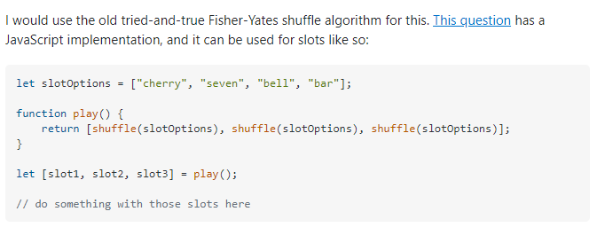

Formula explained: <https://probability.infarom.ro/slots.html>

Paytable examples:

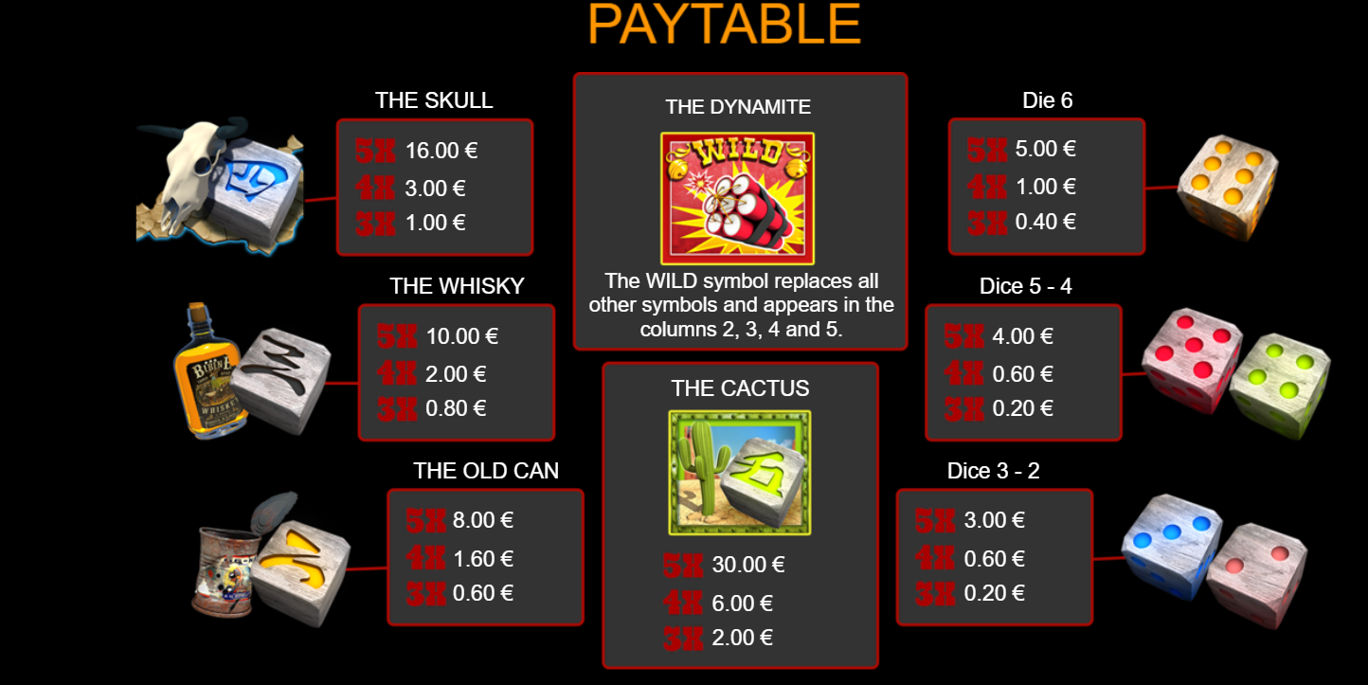

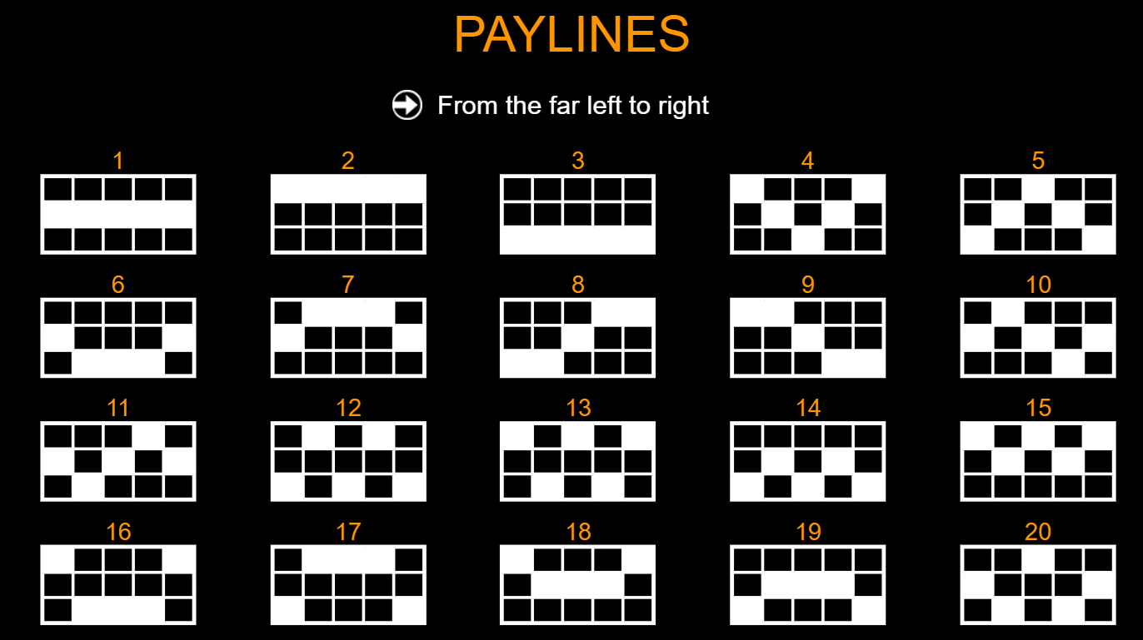

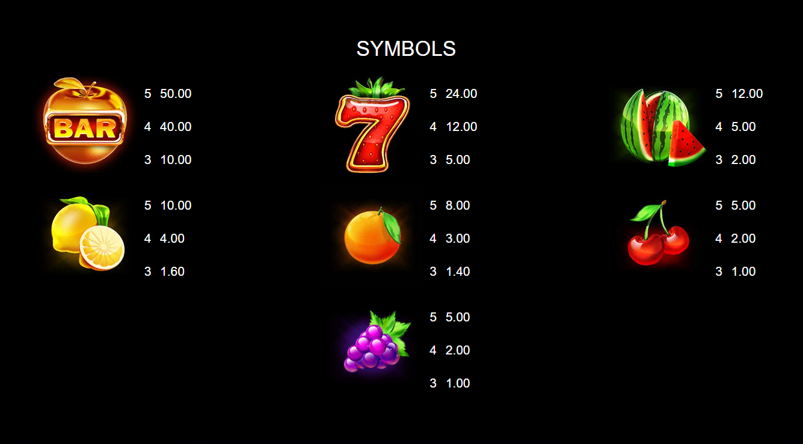

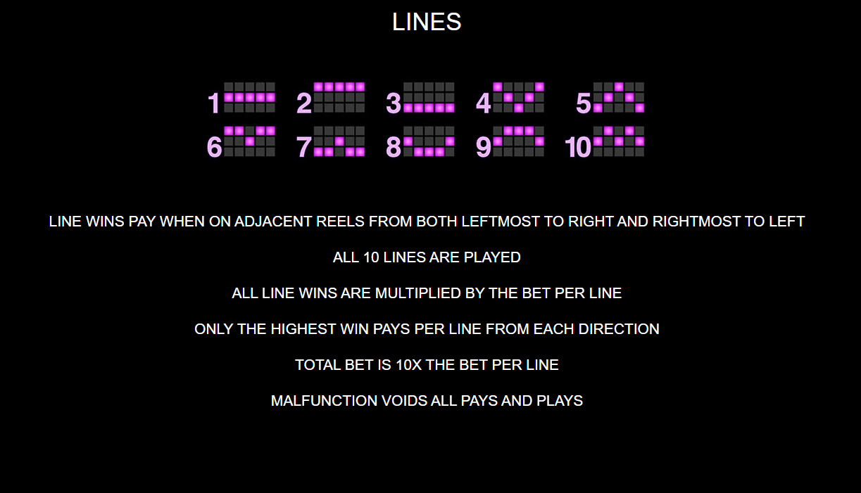

Wild west gold:

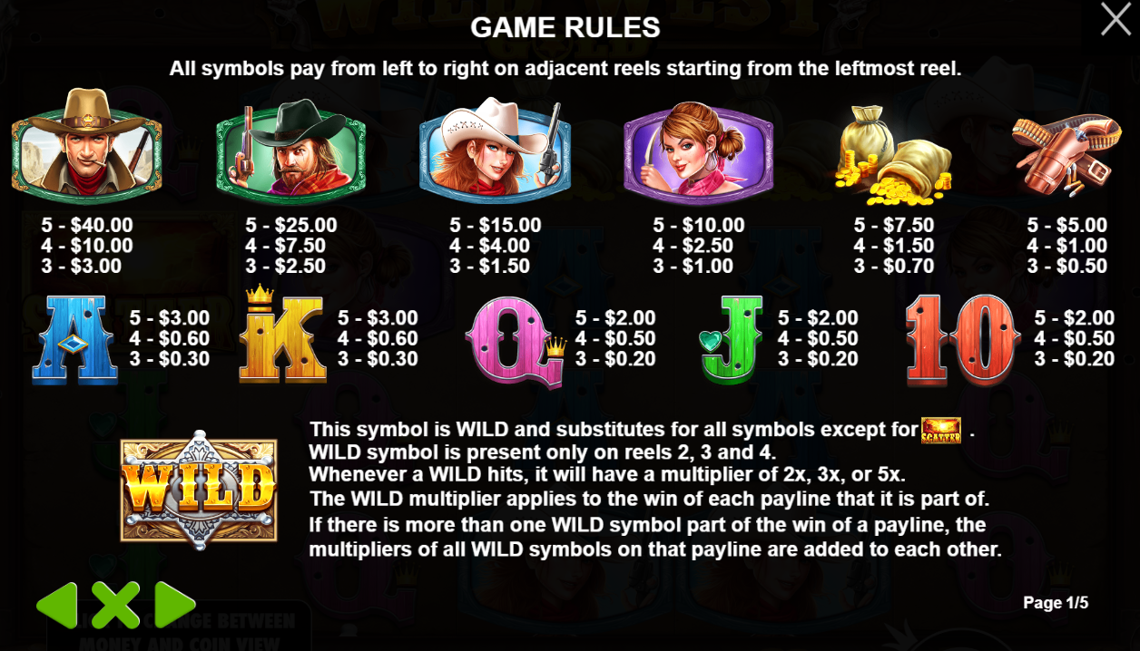

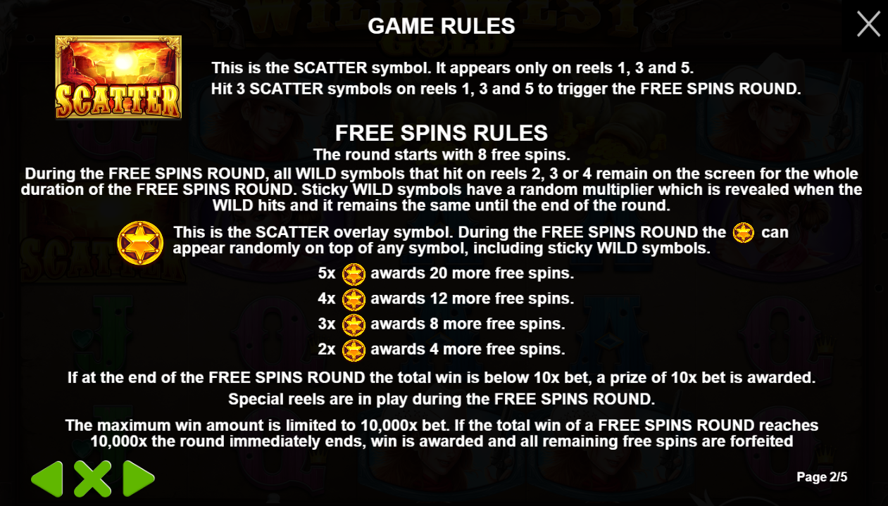

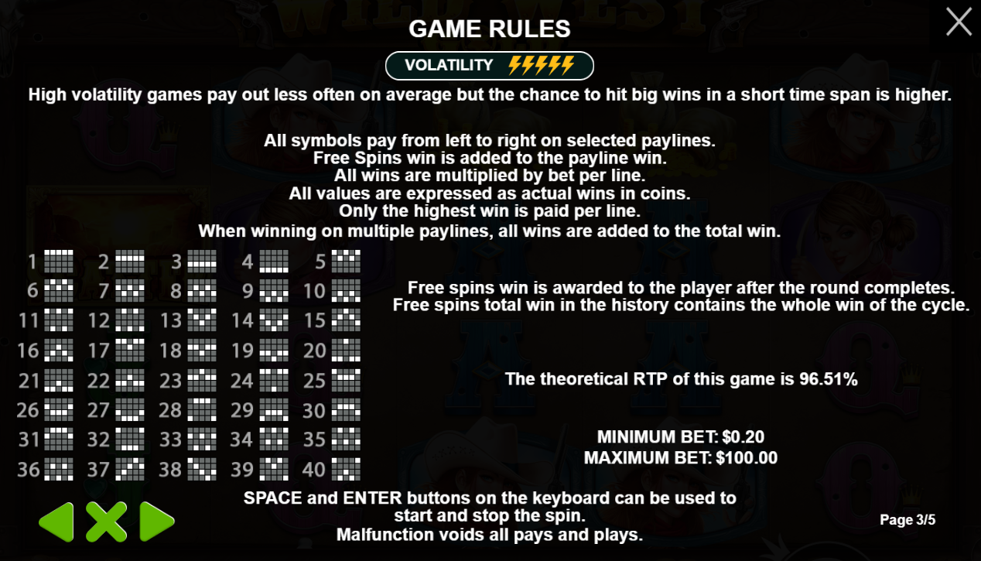





Bounty Gold:

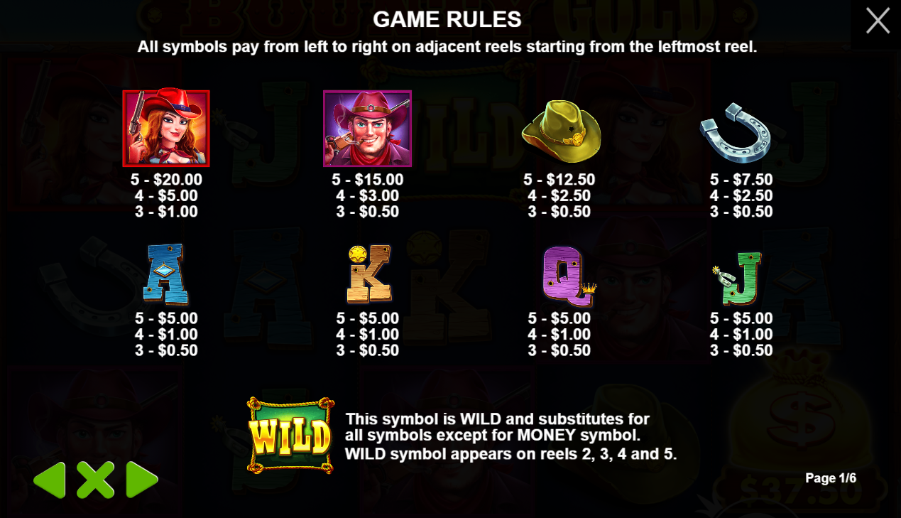

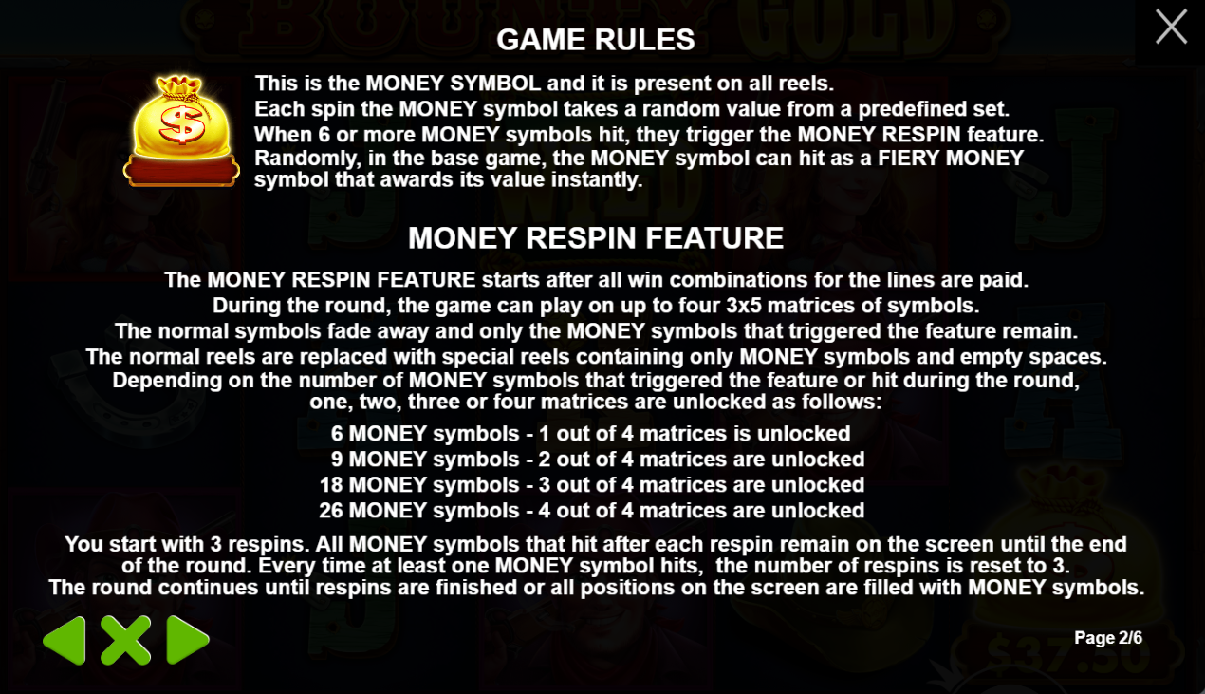

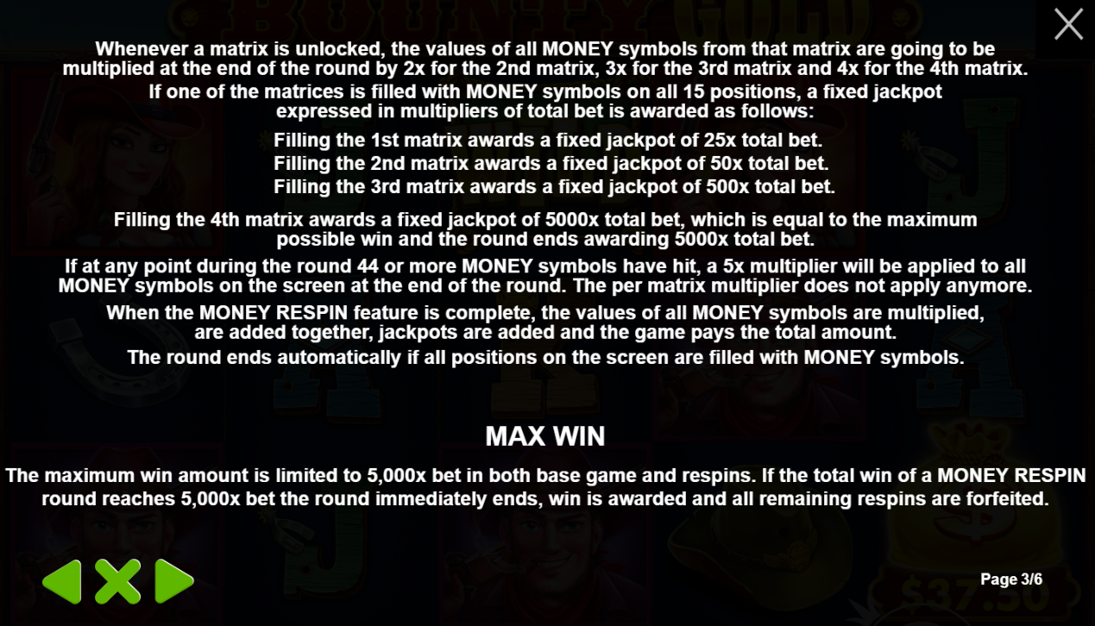

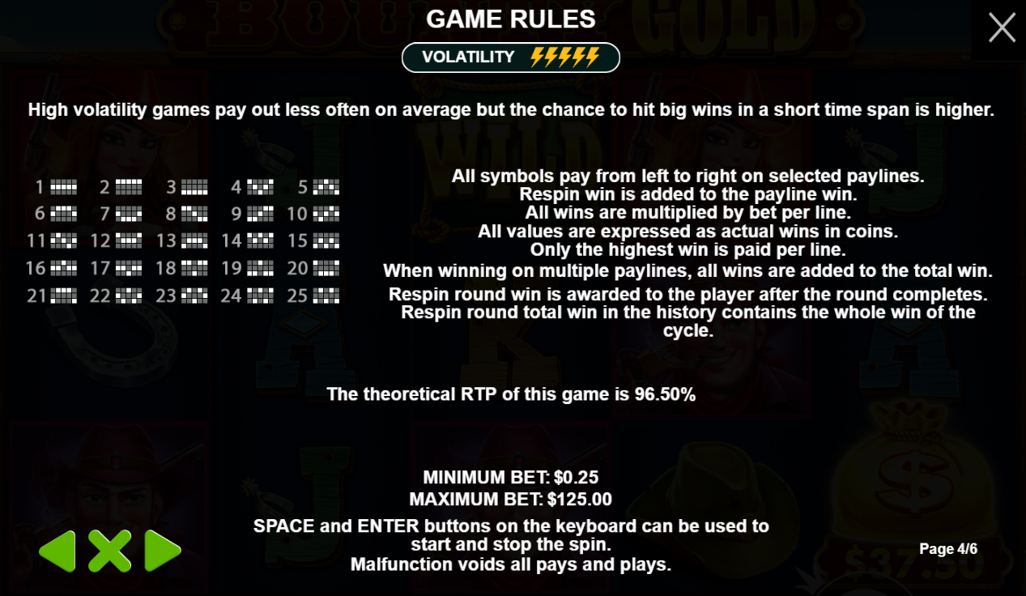





RTP = Return to Player

RTP onder de 95% wordt als “slecht” beschouwd.

Volatility of Variantie: hoe vaak de slot uitbetaald.

Laag = vaker winnen. Gemiddelde winst per keer is laag.

Hoog = minder vaak winnen. Gemiddelde winst per keer is hoog.

Formules:

Coins per spin X Level X winlijnen

Different rtp for jackpot.

Array lengths.

Column 1 stops first, then 2nd, then 3rd,…

SpinRow1

SpinRow2

SpinRow3

SpinRow4

SpinRow5

The length of an array always has to be a multiple of 3.

For example 1

Array lenghts

* SpinRow1: length = 3 x 3
* SpinRow2: length = 4 x 3
* SpinRow3: length = 5 x 3
* SpinRow4: length = 6 x 3
* SpinRow5: length = 7 x 3

Positions it affects:

* SpinRow1: positions = P1, P6, P11
* SpinRow2: positions = P2, P7, P12
* SpinRow3: positions = P3, P8, P13
* SpinRow4: positions = P4, P9, P14
* SpinRow5: positions = P5, P10, P15

Array number of variable p:

* SpinRow1: positions = p0, p5, p10
* SpinRow2: positions = p1, p6, p11
* SpinRow3: positions = p2, p7, p12
* SpinRow4: positions = p3, p8, p13
* SpinRow5: positions = p4, p9, p14

What will happen?

P0 transitions down to p5, p5 positions down to p10, p10 disapears of the screen.

Disappearing off the table with class Reels. So, add overflow: hidden to css

Best practice = transform: translate(%)

Fill each array with a set of random symbols from

New line of thought:

**Possibility 1:**

1 extra row on top of the visible area.

1 extra row on the bottom of the visible area

Let the bottom invisible row loop back to the top.

Let the top loop into frame.

Each time the bottom get’s looped to the top, it needs to be randomized.

Challenges:

* How do we make the array update after every translateY(100%)?
* How do

Tip Daan:

Zorg eerst dat de logica klopt (neglect visuals eerst)

Array per kolom. Toon er 3

Schuif naar onder toon de volgende 3.

**Possibility 2:**

Have a whole bunch of rows on top of the visible area that are invisible.

Let them be randomized.

The visible area get their images fixed. And slides out of frame.

The new visible images become the new fixed images, replacing the old visible area.

Everything else resets position.

Challenges:

* How are we going to get the old images that were shifted to the bottom out of frame, back on top while keeping the visible area the same?
* How are we going to replace the old visible area with the new visible area?
* How to make sure the images don’t flash during reset?

***Hoe ik het zag.***

Array[appel, peer, banaan, pruim, druif]

Array[0] = appel

Array[1] = peer

Array[2] = banaan

Array[3] = pruim

Array[4] = druif

**Fase 2**

Array[0] = peer

Array[1] = banaan

Array[2] = pruim

Array[3] = druif

Array[4] = appel

**Fase 3**

Array[0] = banaan

Array[1] = pruim

Array[2] = druif

Array[3] = appel

Array[4] = peer

***Hoe Daan het ziet***

ItemsArray[]

OriginalArray[appel, peer, banaan, pruim, druif]

Array[0] = appel

Array[1] = peer

Array[2] = banaan

Array[3] = pruim

Array[4] = druif

(1 VisibleArray per row)

VisibleArray1[null, null, null]

VisibleArray2[null, null, null]

VisibleArray3[null, null, null]

VisibleArray4[null, null, null]

VisibleArray5[null, null, null]

**Fase 1**

VisibleArray1[OriginalArray[0], [OriginalArray[1], [OriginalArray[2]]

Let i = 0

VisibleArray1[OriginalArray[i], [OriginalArray[i+1], [OriginalArray[i+2]]

i + 1;

/*

if (i > OriginalArray.length -2){

randomize()

i = 0;

} */

For (let i = 0; i < OriginalArray.length; i++) {

VisibleArray1[OriginalArray[i], [OriginalArray[i+1], [OriginalArray[i+2]]

}

**Begin fase**

OriginalArray[x0, x1, x2, x3, x4]

i = 0

BatchArray[] = randomize() = bij opstart

BatchArray[x4, x0, x2, x1, x4]

// BatchArray.length

Ik klik op de spin button{

VisibleArray[BatchArray[i%5], BatchArray[(i +1)%5], BatchArray[(i +2)%5]]

VisibleArray[x4, x0, x2]

BatchArray[i%5] = Randomize()

i + 1

i = 1

**Fase 1:**

BatchArray[x2, x0, x2, x1, x4]

New random value

VisibleArray[BatchArray[i%5], BatchArray[(i +1)%5], BatchArray[(i +2)%5]]

VisibleArray[x0, x2, x1]

BatchArray[i%5] = Randomize()

i + 1

i = 2

**Fase 2:**

BatchArray[x4, x2, x1, x4, ?]

New random value

VisibleArray[BatchArray[i%5], BatchArray[(i +1)%5], BatchArray[(i +2)%5]]

VisibleArray[x2, x1, x4]

BatchArray[i%5] = Randomize()

i + 1

i = 3

for (

*Modula voorbeeld*

Toon mij i%5

als i = 0 -> 0

als i = 1 -> 1

als i = 2 -> 2

als i = 3 -> 3

als i = 4 -> 4

………..

als i = 5 -> 0

als i = 6 -> 1

als i = 7 -> 3

als i = 8 -> 4

als i = 9 -> 5…

batchArray[] = visibleArray[0, 1, 2, randomize, randomize]

VisibleArray[] is always 3 long

BatchArray[] is always 5 long (2 invisible)

Have they won?

If VA1[0] = VA2[0] && VA2[0] = VA3[0]{

Console.log(‘winner’)

What symbol is it?

While loop to go through them all. To figure out which symbol it is.

Payline 4

VA1[0] = VA2[1] && VA2\

1275 - 616

Paylines visual:

winValue > 0 then show payline.

winValue < 0 then don’t show payline.